**Mr. HelpMate AI**

**Query 1: Can insurance coverage continue during an approved leave?**

**Top 10 Results from the Search Layer for Query-1**

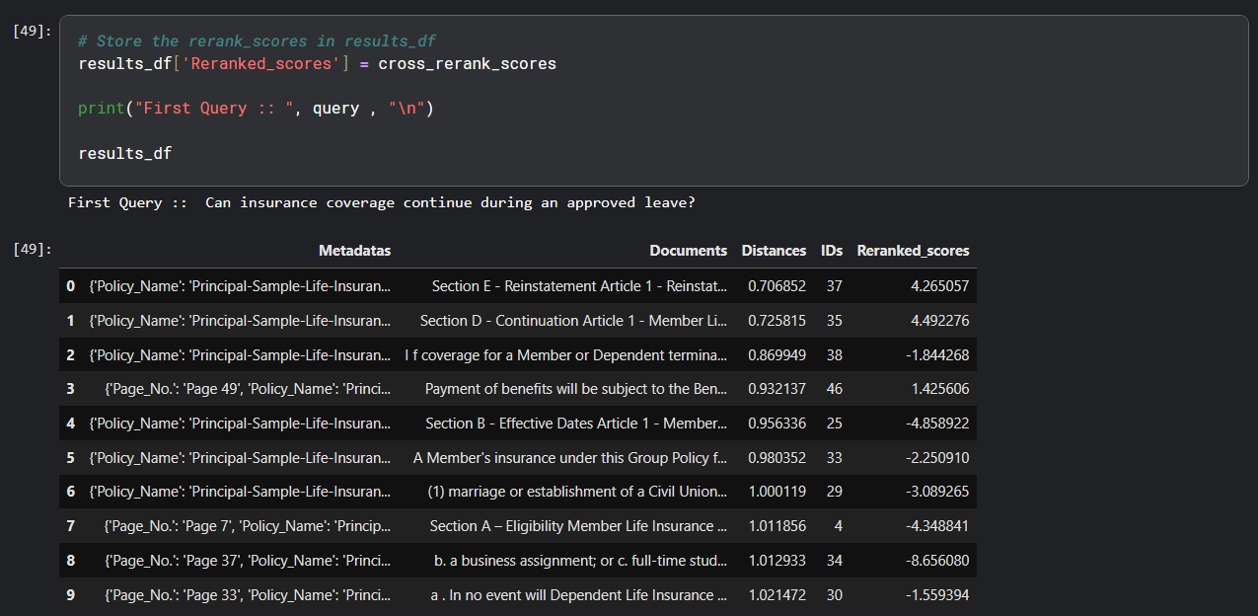

**Top 3 Results Based on Distance and Re-rank for Query-1**

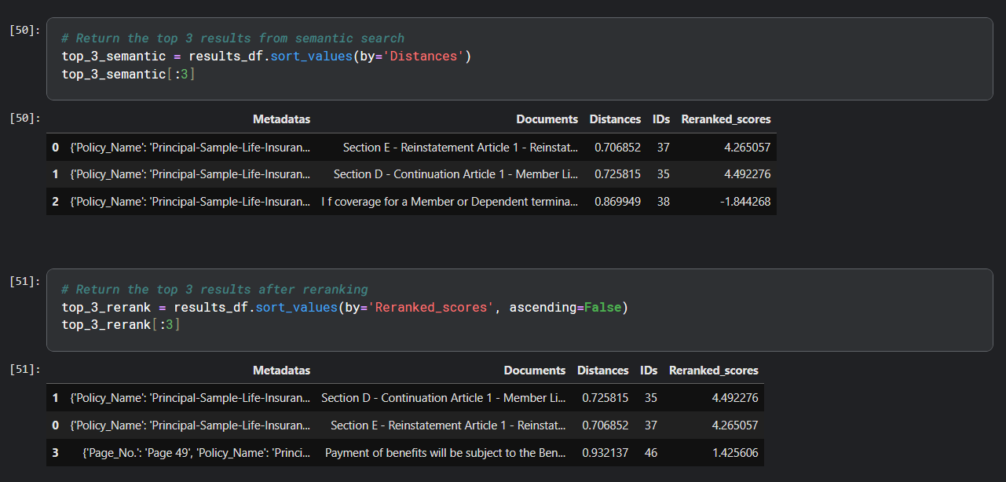

**Final Generated Answer from the Generation Layer for Query-1**

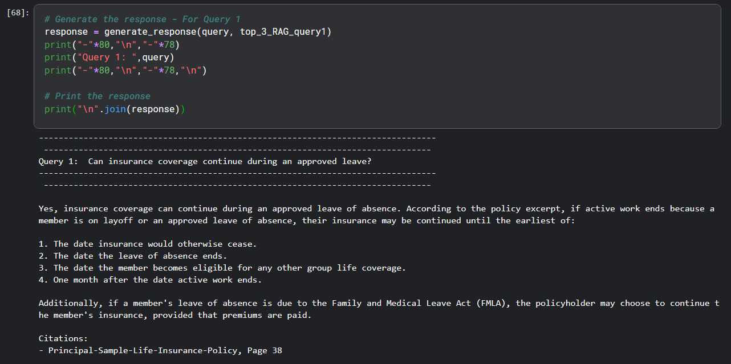

**Query 2: Are there age-based reductions in benefit amounts?**

**Top 10 Results from the Search Layer for Query-2**

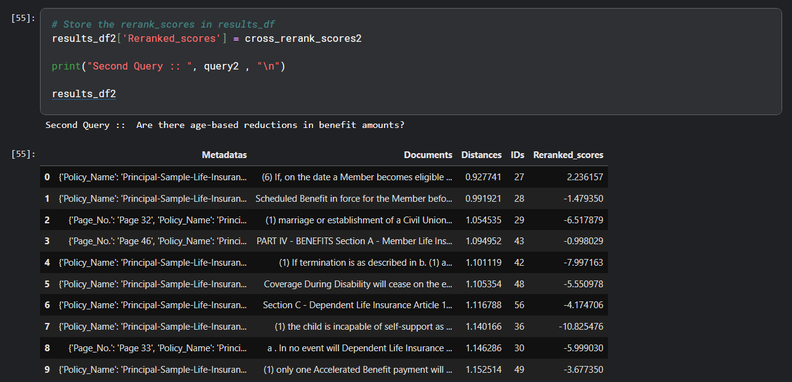

**Top 3 Results Based on Distance and Re-rank for Query-2**

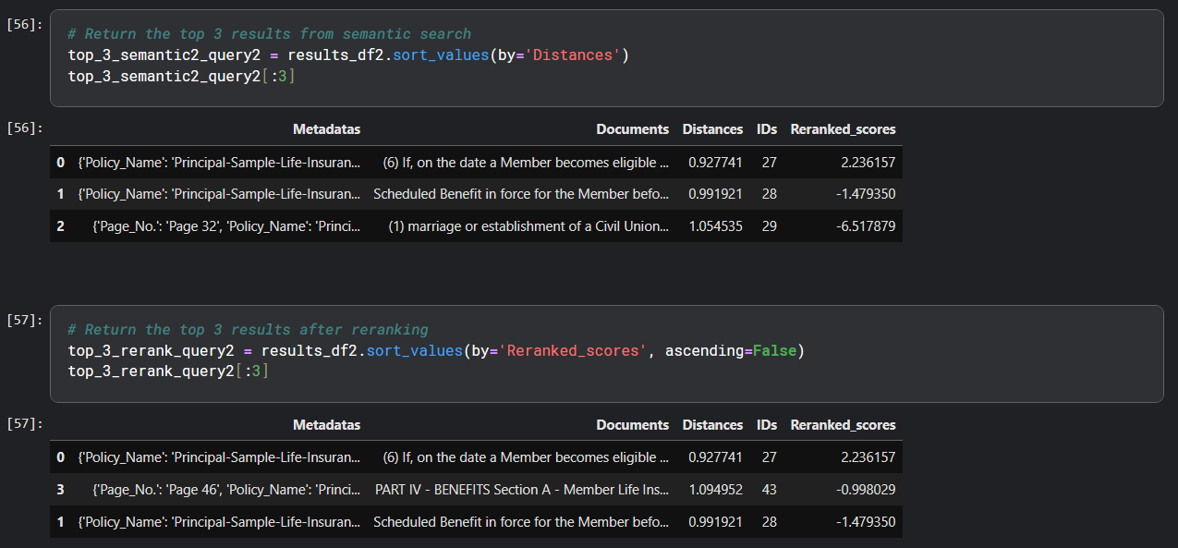

**Final Generated Answer from the Generation Layer for Query-2**

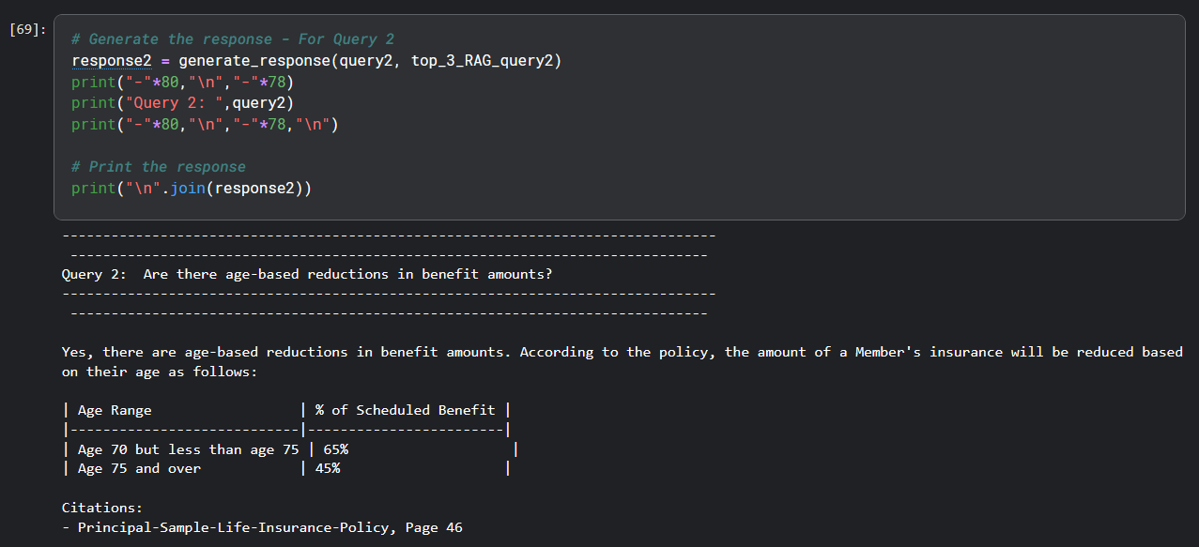

**Query 3: What are the policy exclusions under Accidental Death insurance?**

**Top 10 Results from the Search Layer for Query-3**

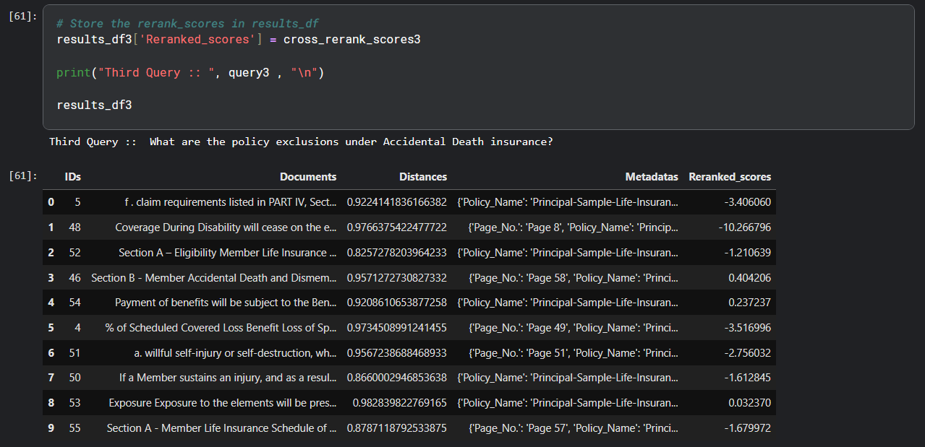

**Top 3 Results Based on Distance and Re-rank for Query-3**

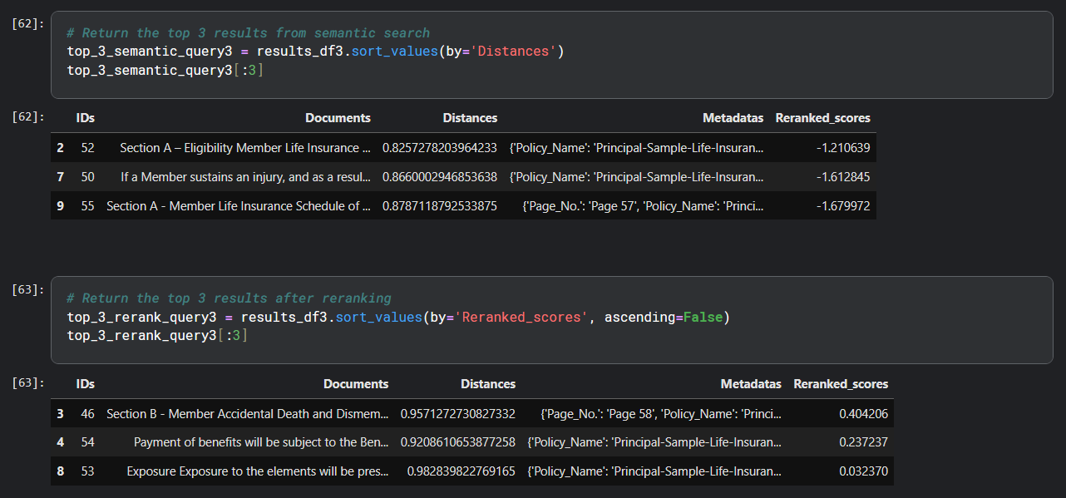

**Final Generated Answer from the Generation Layer for Query-3**

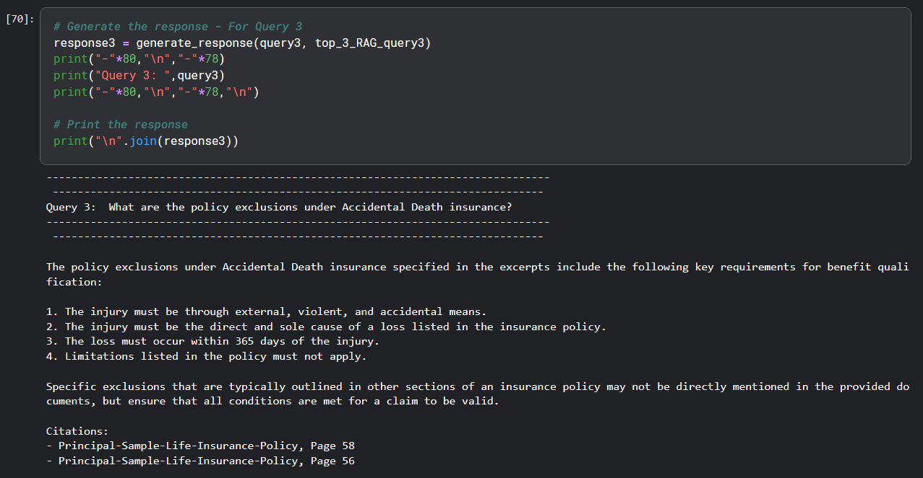

**☺ Thank-you ☺**